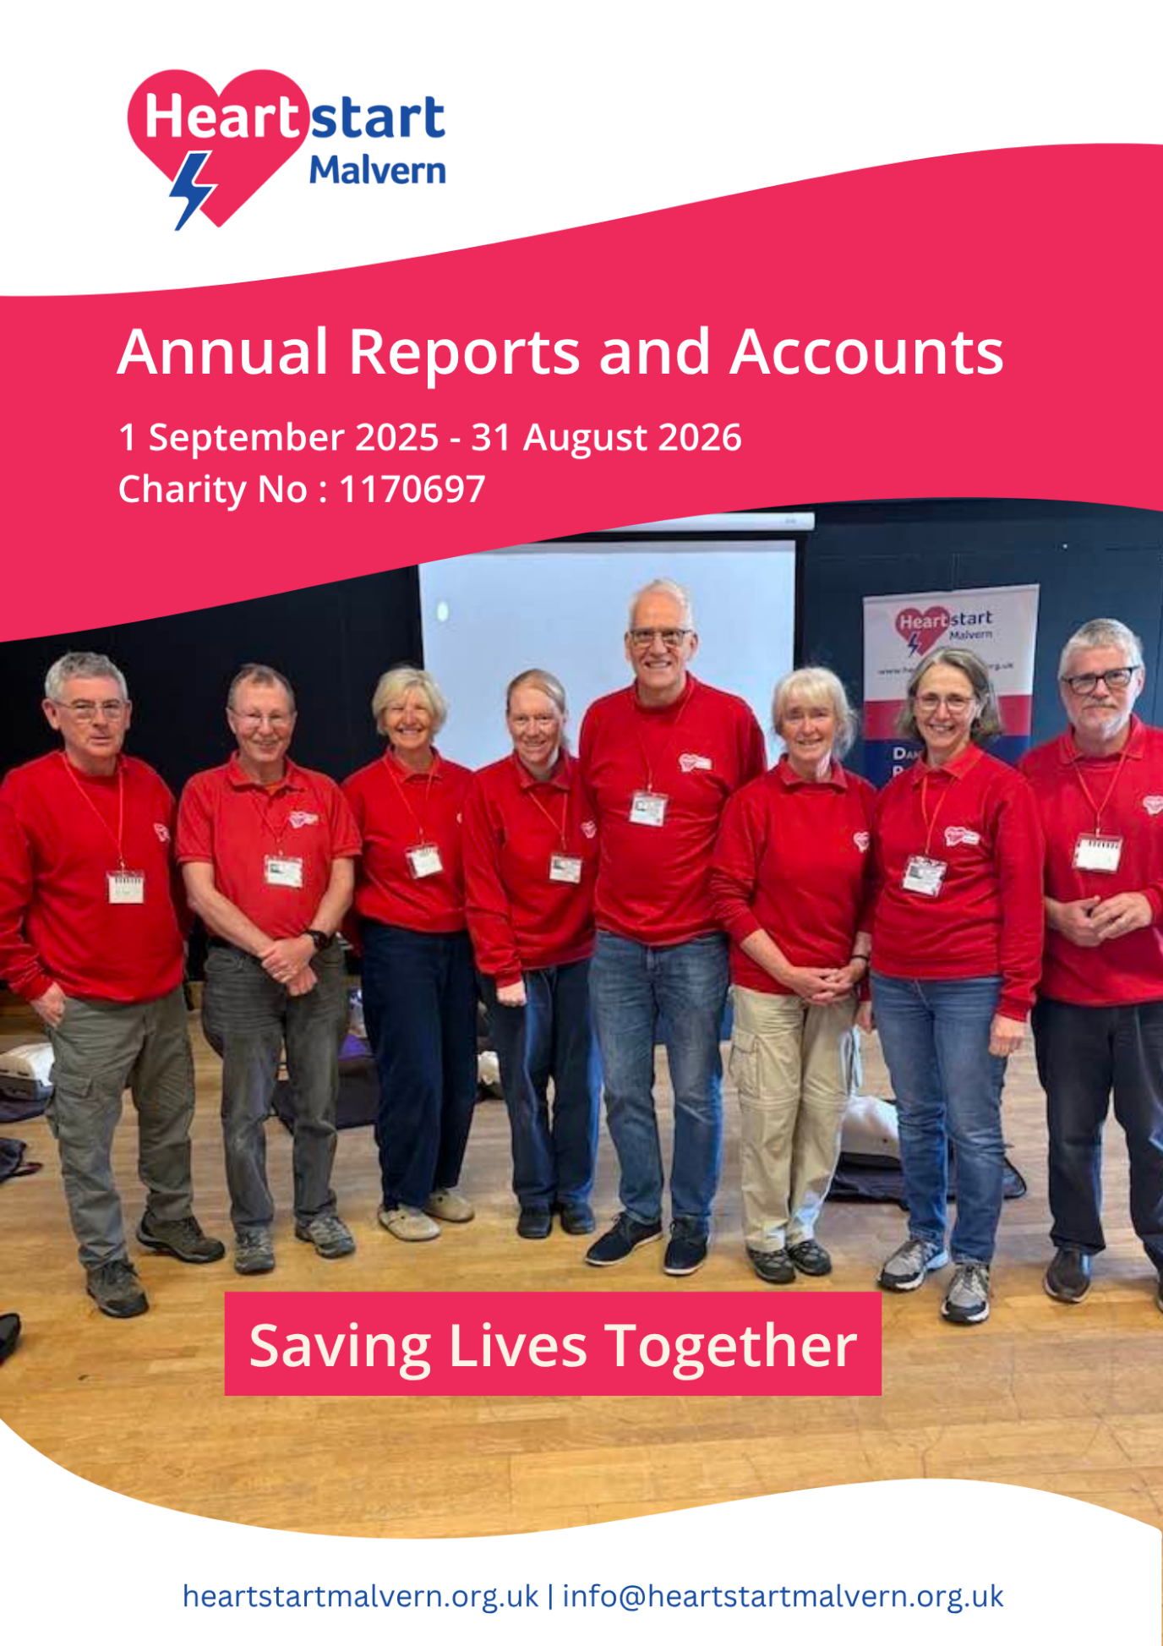
Charity Registration Number: 1170697

Introduction

Heartstart Malvern was founded in 2016 and launched in January 2017. Our aim is to increase the chance of survival for people suffering from a cardiac arrest in Malvern and the surrounding area.

The survival rate from cardiac arrest in the United Kingdom is approximately 10%, and in other European countries it is about 25%. There are some situations in the United Kingdom (e.g. gymnasiums and airports) where the survival rate has been reported to be as high as 70%. This is because of people being trained and starting cardiopulmonary resuscitation (CPR) immediately after the patient has collapsed, and then using a public access defibrillator to restart the patient’s heart.

Heartstart Malvern is trying to increase the survival rate from cardiac arrest in the Malvern area by providing free resuscitation training and installing public access defibrillators. The resuscitation training includes basic cardio-pulmonary resuscitation and how to use a defibrillator. This training is delivered in a variety of settings including schools, community groups and at places of work.

All Heartstart Malvern’s activities are delivered by volunteers, including over 20 trainers and 7 Trustees. This ensures that every single penny donated to Heartstart Malvern will be spent on its charitable objectives rather than staff costs. The contributions made by volunteers are an integral part of Heartstart Malvern’s success.

This Trustee’s Report provides an overview of Heartstart Malvern’s activities for the period 1 September 2025 to 31 August 2026.

Chairman’s Report

Heartstart Malvern provided free Cardiopulmonary Resuscitation (CPR) and defibrillator training to 693 people during the year. The training was provided to individuals, community groups, local businesses and schools. Although the number trained is less than in previous years, it brings the total number of people trained by Heartstart Malvern since its foundation to 7,532, which is a significant number. This number should be much higher but training had to completely stop during the pandemic.

Two large training events during the year attracted almost 200 participants in total. The first was Restart a Heart Day in October and the second was in February as part of Heart Month. The feedback from both events was extremely positive. The February event was attended mostly by members of the Bransford Golf Club who have since raised over £2,306.75 for Heartstart Malvern. This figure is likely to be much higher by the end of 2026.

Our work in schools continues to be strategically important for us. We are now delivering training on an annual basis at Dyson Perrins School and The Chase. Due to timetabling constraints, we were unable to deliver training at Hanley Castle High School this year. We are also delivering training to year six pupils in five local primary schools. We are aiming to offer our training to all Malvern primary schools.

During the year we had to update our lesson plan to reflect the new resuscitation guidelines introduced in autumn 2025. This was done quite quickly and effectively in January 2026.

We have continued to maintain our network of 36 Public Access Defibrillators around Malvern. This involves a small team of volunteers checking every defibrillator each week and replacing consumable parts as and when they need replacing. Our defibrillators were used several times during the year but sadly we are unaware of any successful defibrillation attempts.

This was a particular strong year for the charity financially. During the year 11 local organisations decided to adopted Heartstart Malvern as their Charity of the Year. This raised a staggering £13,932.90 in donations. Some of this income was used to purchase training equipment, three Public Access Defibrillators and to pay for our new website. Heartstart Malvern is extremely grateful to the organisations who supported us last year, and for all of the time and effort put into their fundraising activities.
Despite the decrease in numbers trained this year, this has been a very successful year and has put us in a good position of trying to achieve our aim of training at least 10,000 people and installing 50 public access defibrillators by out by the end of our 10th anniversary year in 2027. Our successes over the last 12 months, would not have been possible without the support of our wonderful volunteers.

Training Activity

During this year, the team provided free training to 693 people. This is 494 fewer people trained than the previous year where 1,187 were trained.

The reduction in the number of people being trained is disappointing. A number of factors have contributed to this including one of the larger school sessions being postponed, and one of our regular business sessions not attracting as many participants as usual due to the timing of the training during their business year. The Trustees have developed an Action Plan to increase training activity during the forthcoming year, so the total number trained during the year will be nearer to the number trained in 2025 (1,187).

The total number of people trained by Heartstart Malvern is now 7,532. This number would have significantly higher but the pandemic restricted our training activities between our reporting years between 2020 and 2023. Graph 1 below shows the number of people trained by Heartstart Malvern since its launch in 2017.

Training has been delivered in a variety of settings including schools, youth groups, community groups and local businesses, as well as open public sessions which individuals can attend.

Heartstart Malvern is particularly proud of its work in local schools. Training in school is an important part of our strategy. Our aim is to train the next generation of lifesavers by delivering training to all year six pupils and secondary school pupils at least once during their secondary education. In the coming year, we will need to focus on approaching local primary schools where we are currently not delivering training and ensuring that our training is embedded into the curriculum for local secondary schools.

During the year, training was delivered to 264 pupils at the following schools:

- Dyson Perrins Church of England Academy
- The Chase
- Northleigh Primary School
- Malvern Wells Primary School
- Madresfield Primary School
- Suckley Primary School
- The Downs Independent School

Training Evaluations

All our training sessions, except school sessions, are evaluated. The following data is collated from 394 completed evaluations (92% response rate). Heartstart Malvern is planning to evaluate future training activity in schools.

Graph 2 below illustrates that more females (61%) are being trained than males (39%). This is possibly due to many groups where the membership is predominately female (e.g. Women’s Institutes) include a Heartstart Malvern training session as part of their annual programme of events.

Graph 3 below shows that most people trained (41%), excluding our school sessions, are in the 51-70 age bracket. A further 38% were aged over 71. Therefore, over 79% of people trained at our public sessions or through a training session at a community group, were over 50 years of age. This is the probably the group most likely to witness a cardiac arrest. With 80% of all cardiac arrests happening at home, there may be a need to target more training at groups which traditionally attract members over the age of 50 years.

If schools had been included in this sample, it is likely that the 12-18 group would have been significantly higher.

Graph 4 below illustrates that 34% of people attending our training sessions have never been taught CPR before. Based on the sample size of 394, this means that, excluding schools, we have trained approximately 134 people in basic resuscitation techniques who have never been trained before. It was encouraging to see so many people returning for refresher training too.

Graph 5 below illustrates that 69% of participants have never been trained to use a defibrillator before. Based on the sample size of 394, this means that, excluding schools, we have trained approximately 272 people how to use a defibrillator, who have never been trained before.

Graph 6 above below shows a significant shift in respondents’ confidence to undertake CPR before their training session (34% confident) compared to after their training (96% confident). There was a slight reduction in pre and post training confidence of 3% compared to previous year. This could be a consequence of the national resuscitation guidelines and recognising abnormal breathing as a sign of a cardiac arrest.

Graph 7 below shows a significant shift in respondents confidence to use a defibrillator before their training session (20% confident) compared to after their training (97% confident).

Other data collected from this evaluation indicates that:

- 100%of respondents would recommend Heartstart Malvern’s training to their friends and family
- Many of the qualitative comments recorded described the training as ‘excellent, informative and reassuring. There were many comments made about how good the trainers were.

Public Access Defibrillators

Heartstart Malvern did not install any new public access defibrillators during the year. Three defibrillators were purchased in August 2026 and will be installed early in our next reporting period.

Heartstart Malvern continued maintaining our existing defibrillators of 36 public access defibrillators. Every defibrillator is checked weekly to ensure it is ready to be used in an emergency, by one of our volunteers. The defibrillators always must be checked after we have been notified by the ambulance service that they may have been used. Where necessary, we replace any defibrillation pads which have been used or have expired. Batteries are also replaced every five years. Maintaining and replacing defibrillators will be a significant ongoing cost which the charity will need to plan for.

During the year our defibrillators were deployed numerous times but we are unaware of any successful defibrillation attempts. We are going to record the actual number of deployments going forward.

One of our biggest challenges remains identifying suitable locations in residential areas to locate public access defibrillators. With 80% of all cardiac arrests happening at home, it is important for Heartstart Malvern to continue to locate defibrillators in residential areas, where they are most likely to be used. During the year we engaged in discussions with Worcestershire County Council about installing our defibrillator cabinets next to lampposts. The additional costs involved with this proved to be prohibitive. During the next reporting period we will be looking at placing defibrillators on private properties.

Financial Review

Balance Sheet for the years 1 September 2025 – 31 August 2026

Income |  |  |  | Expenditure
Donations from TPF* | 13,932.90 |  | PAD Defibrillators & Cabinets |  | 3672.00
Donations from Trusts | 3,000.00 |  | PAD Consumables |  | 1925.07
Donations from sessions | 1,586.30 |  | Training equipment |  | 5,000
Corporate Donations | 1,000.00 |  | Training consumables |  | 1,567.47
In Memoriam Donations | 822.00 |  | Training printing and uniforms |  | 952.17
 |  |  | Insurance |  | 764.54
 |  |  | Website and Just Giving |  | 410.75
 |  |  | Room Hire |  | 291.00
 |  |  | Web Design |  | 2,000.00
 |  |  | Miscellaneous |  | 107.72
Total Income | 20,341.20 |  | Total Expenditure |  | 16,690.72
 |  |  | Excess income (profit) |  | 3,650.48
 | 20,341.20 |  |  |  | 20,341.20
Opening bal. (01.09.25) | 6,932.88
Excess Income (Profit) | 3,650.48
Closing balance (31.08.26) | 10,583.36

*=TPF = Third party fundraising

Income

This was a good year financially, with our total income being £20,341.20 (£11,097.72 previous year) and expenditure being £16,690.72 (£9,279.30 previous year). This resulted in a surplus of £3,650.48 (£1,818.42 previous year). This represents significantly better financial position than in previous years. Therefore, based on this years expenditure, it is likely that Trustees will agree a reserve of about £10,000 for the coming year.

The closing balance of £10.583.36 was over the £9,000 reserve agreed by the Trustees during the year. A slightly higher reserve was maintained to cover the cost of some additional expenditure, associated with our website upgrade, which will be due for payment early in our next reporting period. The reserve is set aside to cover a full 12 months expenditure for the charity, and is usually based on the highest annual expenditure in the last three years.

As with previous years, our largest source of income for the year was from third part fundraising (TPF). During the year, we received £13,932.90 (£4,167.16 previous year) from third party fundraising.

Third party fundraising is where local organisation undertake fundraising events for Heartstart Malvern. Organisations who raised money for Heartstart Malvern during this reporting period included:

- Malvern Town Council £2,727.59
- Bransford Golf Club £2,306.75
- Co-op Community Fund £2,150.71
- Colwall Cricket Club £1,350.00
- Malvern Buzzards £1,287.11
- Paramedic Society £1,110.74
- Upton Young Farmers £1,050.00
- Malvern Joggers £805.00
- Matrix Network Group £800.00
- Upton Discussion Group £195.00
- Hanley Castle Anglers £150.00

Heartstart Malvern was one of three local causes supported by the Co-op during their operating year. We had received £500 from the Co-op during our previous reporting year. The total amount received from the Co-op as part of their good causes scheme was therefore £2.650.71.

The donation of £2,306.75 by Bransford Golf Club is part of Heartstart Malvern being their Senior Captains Chairity of the year. The overall donation from the club is likely to be significantly higher by the end of the calendar year

Heartstart Malvern are incredibly thankful to all of the above organisations for their donations which has helped to allow us to continue to offer our training free of charge and to maintain our network of defibrillators. An enormous amount of time and effort was needed by each organisation to raise this money.

A significant grant of £3,000 was received from the Edward Cadbury Trust during the year. The total value of grants from Trusts in the previous year was £3,000.

Although we provide our training completely free of charge, we do receive donations from training sessions. Donations from training sessions totalled £1,586.30 which covered the costs of training consumables (i.e. training defibrillator pads, batteries and manikin wipes). It did not cover the cost of printing (£952.17) and insurance (£764.54). The total amount received from training sessions is lower than previous years but this is likely to be due to the smaller number of people trained.

A corporate donation of £1,000 was received from Inspirational Vet Care. This donation was received after The Avenue Vets nominated Heartstart Malvern as a local good cause. We have a defibrillator located at Avenue Vets.

Expenditure

Our main expenditure this year was on three new defibrillators and cabinets (£3,672.00). We did not purchase any defibrillators in the previous year.

The Trustees also allocated £2,000 as part payment towards the total cost of a new website. Our existing website is 10 years old, and although had served the charity well, needed updating. The Trustees believe the new website will assist with promoting our courses and assisting with fundraising.

The purchase of the three new defibrillators and updating of our website was only possible through the generosity of the organisations listed above and their fundraising activities.

The cost of replacing defibrillator pads and batteries for our 36 public access defibrillators was £1,925.07 and represented another significant expense. This was slightly lower than the £2,161.75 figure for the previous year. The Trustees are mindful that some of our defibrillators are coming to the end of their 10-year warranty and we will need to start a programme of replacing these within the next few years. We are also anticipating having to replace a significant number of defibrillator batteries over the next 12 months as they come to the end of their working life.

The majority of the remaining expenditure related to training. This included £5,000 (previous year £1,625.00) used for training equipment, £1,567.47 (previous year £2,622.43) for training consumables and £952.17 (previous £1,690.82) for printing and uniforms. £291.00 was spent on room hire.

Other overheads for the charity included Insurance £764.54, website and Just Giving Platform fees £410.75 and miscellaneous items £107.72.

Our greatest financial challenge remains trying to secure regular monthly income. This will become increasingly important as we anticipating increasing the number of Public Access Defibrillators. We have been extremely fortunate to have been supported by a number of local organisations holding fundraising events for us and receiving grants from other charitable trusts. However, this income cannot be guaranteed for future years.

Overall, the Trustees believe that our expenditure is well controlled and we are pleased that we have manged to return a surplus for the year despite our expenditure increasing. The charity is in good financial health and this needs to be maintained for the next 12 months.

Structure, Governance and Management

Heartstart Malvern is a Charitable Incorporated Organisation and its work is guided by a Constitution. Volunteers are asked to become a Trustee as and when a vacancy arises. Applications are then considered at a Trustees Meeting and formally approved at the next Annual General Meeting. Trustees generally meet once a quarter.

In February 2026 at our AGM, Mrs Jean Williams sadly resigned as a Trustee. Jean was a founding Trustee of Heartstart Malvern and a dedicated trainer. She made an enormous contribution to the development of Heartstart Malvern. Jean was replaced by Dr David Grier who is an experienced and committed trainer.

There were 8 Trustees during this reporting period:

- Richard Vakis-Lowe (Chair)
- Catherine Millar (Secretary)
- David Bijl (Treasurer)
- Susan Cole (Schools Lead)
- Kate Conway (Clinical Governance Lead)
- Ian Blance (Organisational Governance Lead)
- David Grier (Health Inequalities)
- Jean Williams (resigned February 2026)

Summary

This has been another successful year for the charity in terms of the number of people trained and the strengthening of our financial position. Our success can only be contributed to the amount of time and energy given to the charity by our volunteers and from the support of numerous local organisations who have supported Heartstart Malvern with some very generous donations. Without the support from all our volunteers and local organisations, the Charity would not exist.

The feedback from our training surveys is very encouraging, with almost all participants leaving their training session confident to undertake CPR and use a defibrillator. It is very difficult to get feedback about when people have used these skills in real life. Although we did not receive reports of any lives being saved by people who have attended a Heartstart Malvern training session over the last 12 months, we are aware of lives that have been saved in previous years and are confident that as we train more people, that more lives will be saved in the future.

The Trustees set some very ambitious targets of training at least 10,000 people and installing 50 public access defibrillators by the end of our tenth anniversary in 2027. We have made good progress over the last 12 months and are well on track to achieving this.

What Heartstart Malvern is doing in Malvern is very unique. There are very few other charities who are training such large numbers and installing public access defibrillators. Trying to improve the survival rates from cardiac arrests is very much a marathon and not a sprint. We have made significant progress with our marathon and it will not be long before we will be able to report more lives being saved every year.

The Heartstart Malvern Trustees would like to express their deepest gratitude to all the charity’s volunteers, many of whom have given up an enormous amount of their own time to deliver training sessions, maintain our defibrillators and helping to ensure Heartstart Malvern’s sustainability.

Richard Vakis-Lowe
Chairman Heartstart Malvern
on behalf of Heartstart Malvern Trustees
21 October 2026

